[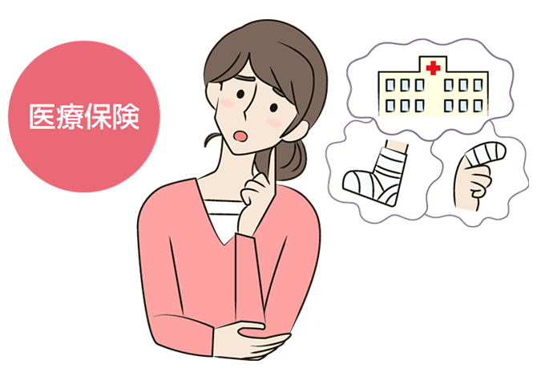](https://www.google.co.jp/url?sa=i&url=https://r-hoken.jp/advice/column/insurance_013/&psig=AOvVaw1bYUq7VSa9DlvBOfnPzZHD&ust=1601367423262000&source=images&cd=vfe&ved=0CAIQjRxqFwoTCJjCy-q0i-wCFQAAAAAdAAAAABAP)

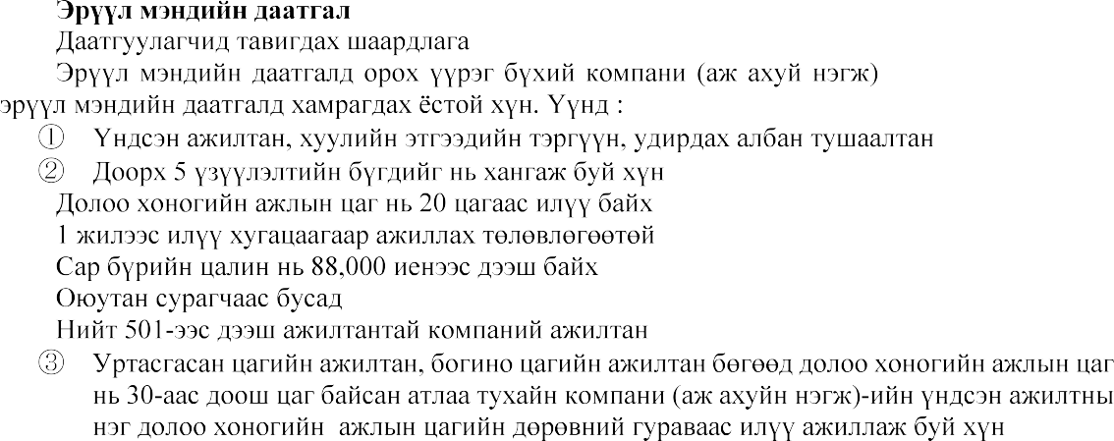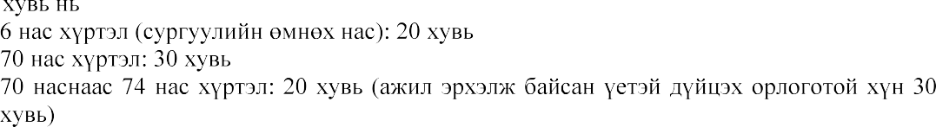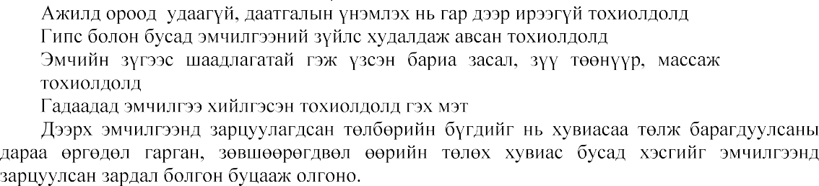



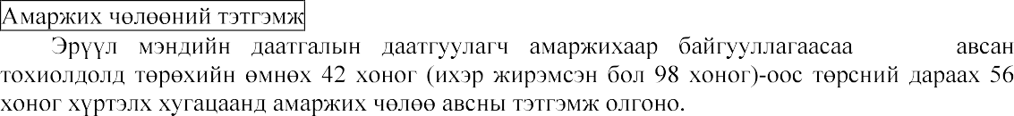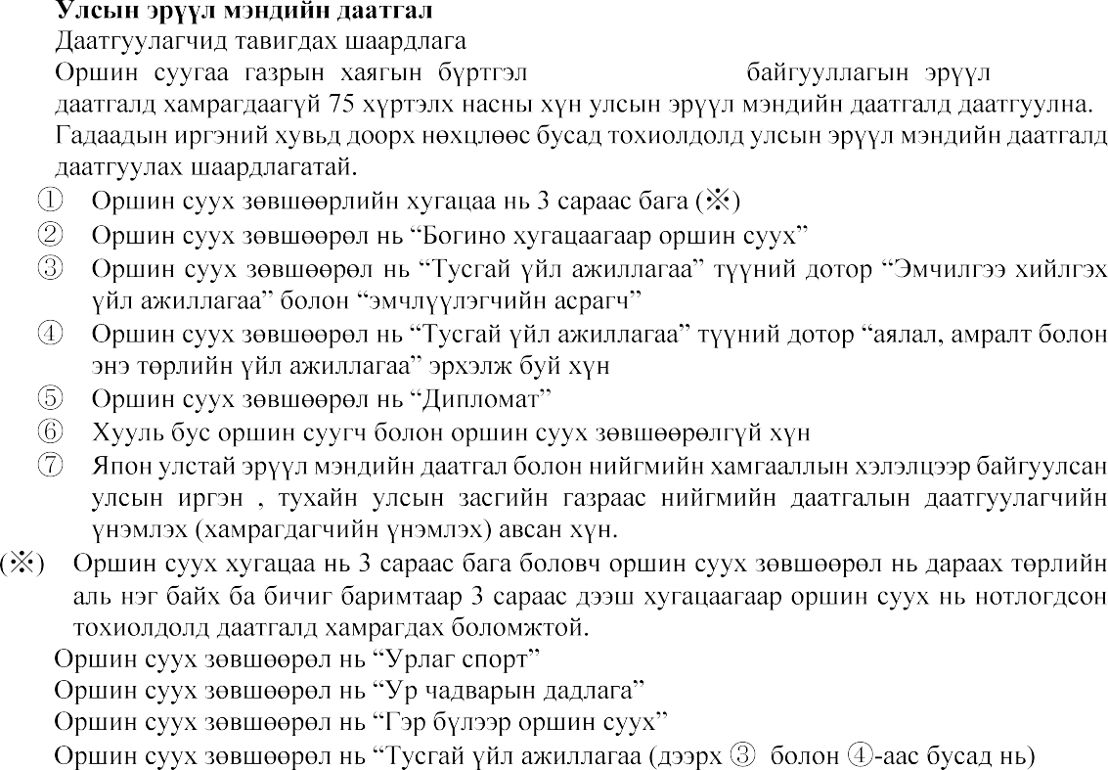



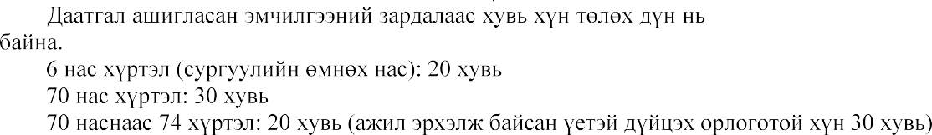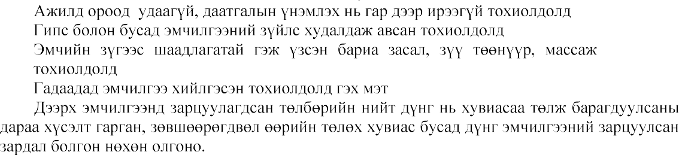

[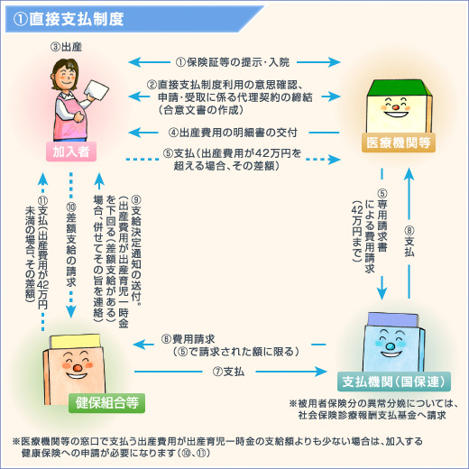](https://www.google.co.jp/url?sa=i&url=https://www.kenporen.com/health-insurance/shussan-ikuji/&psig=AOvVaw0qp7H2l6VlYZfoLRVa_LUH&ust=1601368075078000&source=images&cd=vfe&ved=0CAIQjRxqFwoTCICBlYy3i-wCFQAAAAAdAAAAABAV)Анхаарал тавьсанд баярлалаа.

