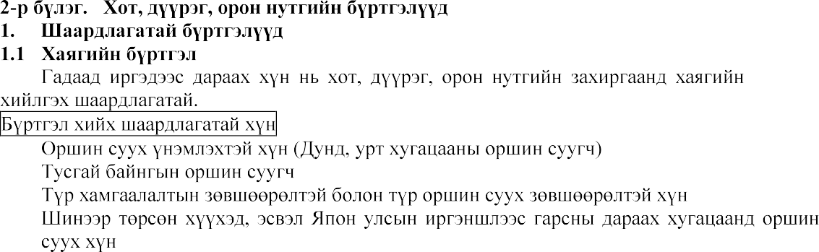

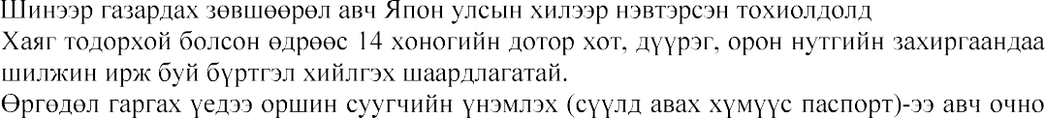

[](https://www.google.co.jp/imgres?imgurl=https%3A%2F%2Fhikkoshi.suumo.jp%2Foyakudachi%2Fshm-article-admin%2Fwp-content%2Fuploads%2F2016%2F06%2F1773_main2.jpg&imgrefurl=https%3A%2F%2Fhikkoshi.suumo.jp%2Foyakudachi%2F1773.html&tbnid=3bGhHLyt3tgf2M&vet=12ahUKEwjI2ZOR4aHsAhVWEKYKHSt6CywQMyhnegUIARCeAQ..i&docid=eCPJd-MQ1mCFJM&w=2000&h=1467&q=%E4%BD%8F%E6%89%80%E7%99%BB%E9%8C%B2%E3%81%AE%E5%B1%8A%E5%87%BA&ved=2ahUKEwjI2ZOR4aHsAhVWEKYKHSt6CywQMyhnegUIARCeAQ)

