[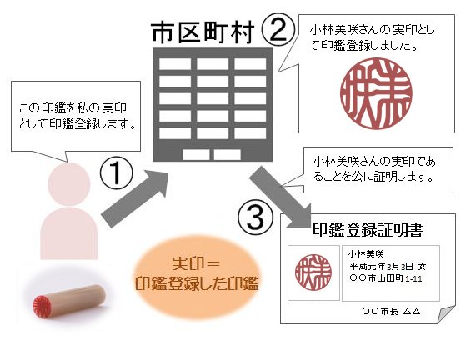](https://www.google.co.jp/url?sa=i&url=https://namae.kaiunya.jp/2013/12/inkantouroku/&psig=AOvVaw1GZIN3FTI1ZEeiTSuEoQMf&ust=1602136302204000&source=images&cd=vfe&ved=0CAIQjRxqFwoTCOihyZHloewCFQAAAAAdAAAAABAD)

