[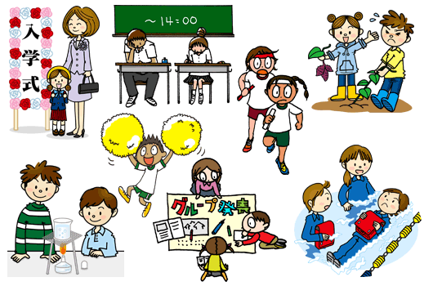](https://www.google.co.jp/url?sa=i&url=https://www.justsystems.com/jp/school/members/tool/index.html&psig=AOvVaw3UsxuatcO5Aoa1-Tvl9h5L&ust=1602221615053000&source=images&cd=vfe&ved=0CAIQjRxqFwoTCMCXnPSipOwCFQAAAAAdAAAAABAV)