2.1

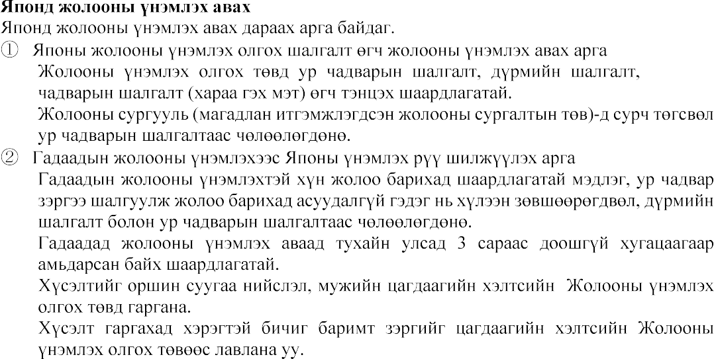

[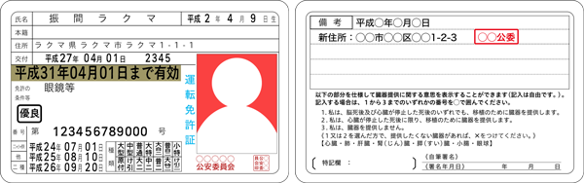](https://www.google.co.jp/url?sa=i&url=https%3A%2F%2Ffaq.fril.jp%2F4309%2F&psig=AOvVaw3gn1-lYYK8atbv3Dwgn3q8&ust=1602642171348000&source=images&cd=vfe&ved=0CAIQjRxqFwoTCKD7-NzBsOwCFQAAAAAdAAAAABAS)

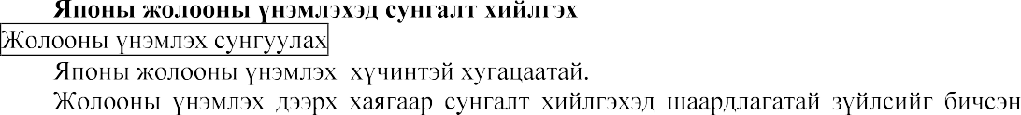



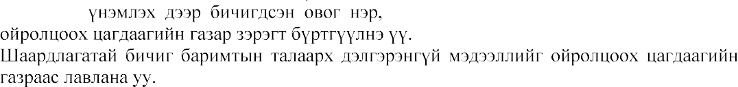

2.3

