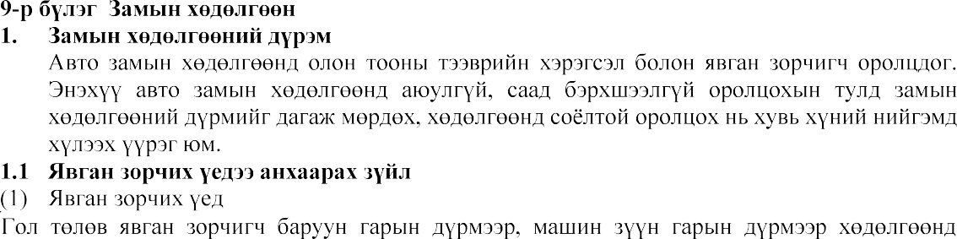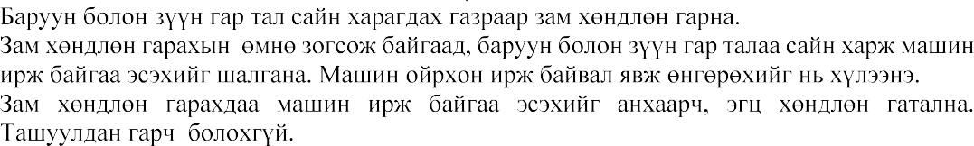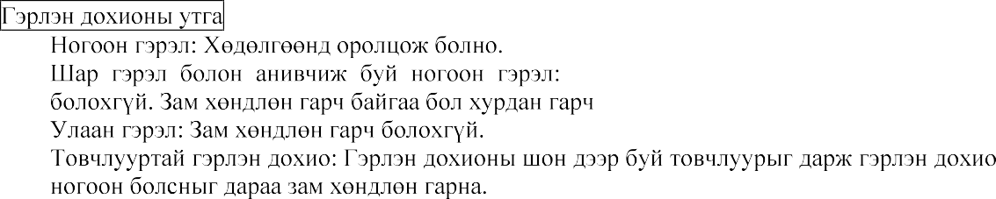

[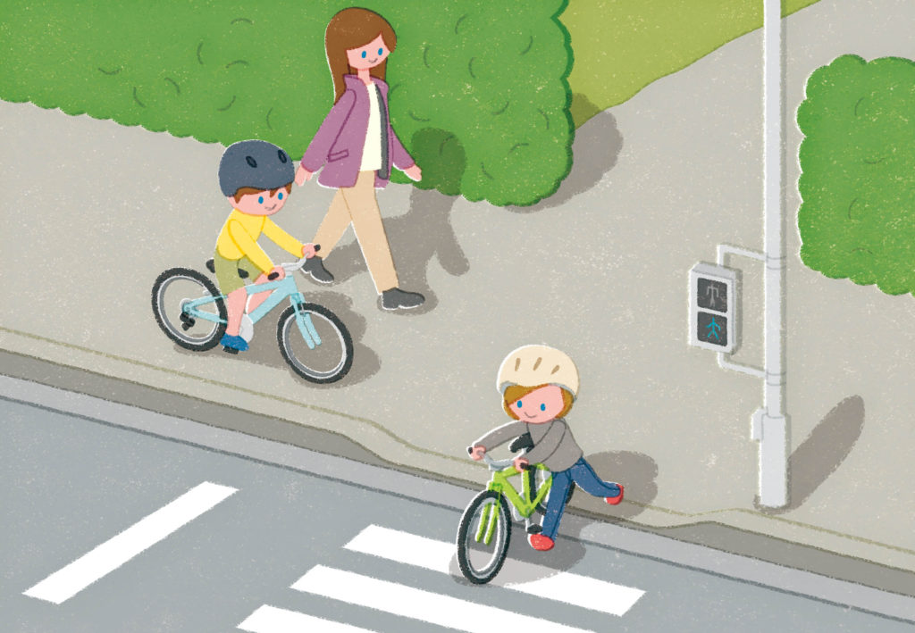](https://www.google.co.jp/url?sa=i&url=https%3A%2F%2Fjksa.org%2Fpublicroad%2F&psig=AOvVaw16gPvX20jabASKoxVCE1cM&ust=1602648456132000&source=images&cd=vfe&ved=0CAIQjRxqFwoTCMjuqYDZsOwCFQAAAAAdAAAAABAe)

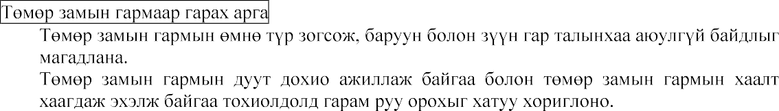

[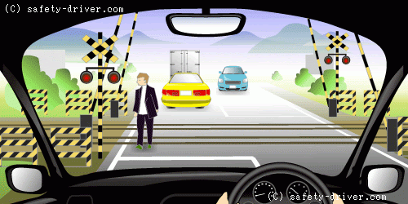](https://www.google.co.jp/url?sa=i&url=http%3A%2F%2Fwww.safety-driver.com%2Fmenkyo%2F3%2Fchangetracking.html&psig=AOvVaw2YFzhMuqpkB3VR7Xh3YYl9&ust=1602648908683000&source=images&cd=vfe&ved=0CAIQjRxqFwoTCPDRv9TasOwCFQAAAAAdAAAAABAK)



