[](https://www.google.co.jp/url?sa=i&url=https://www.shares.ai/lab/3329242&psig=AOvVaw1celQV7RrALeByXtkuTYIp&ust=1602751987097000&source=images&cd=vfe&ved=0CAIQjRxqFwoTCIDhnsvas-wCFQAAAAAdAAAAABAD)

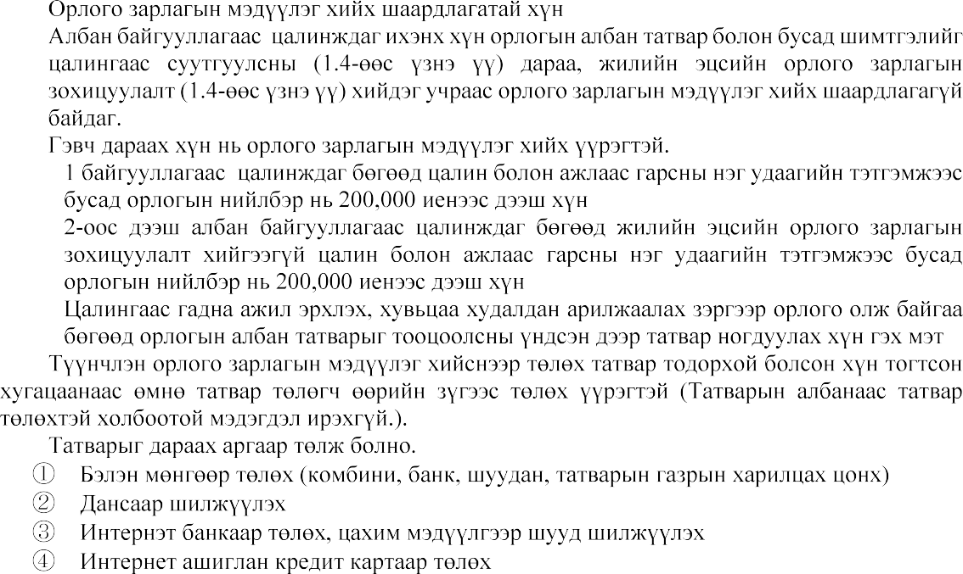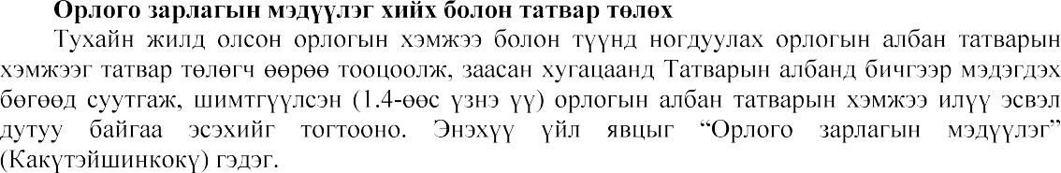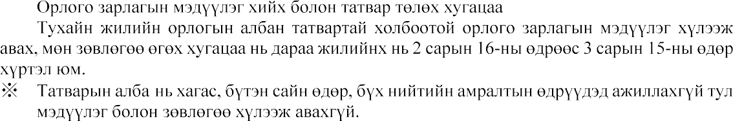

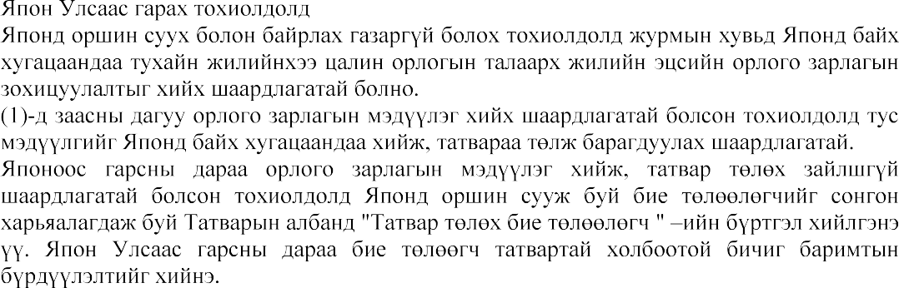

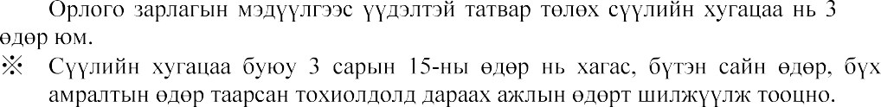

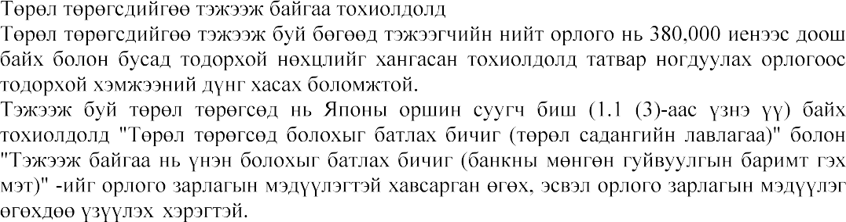

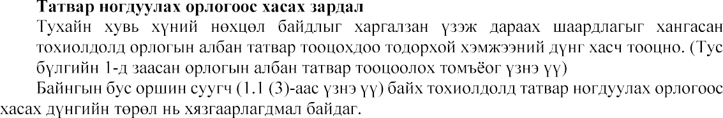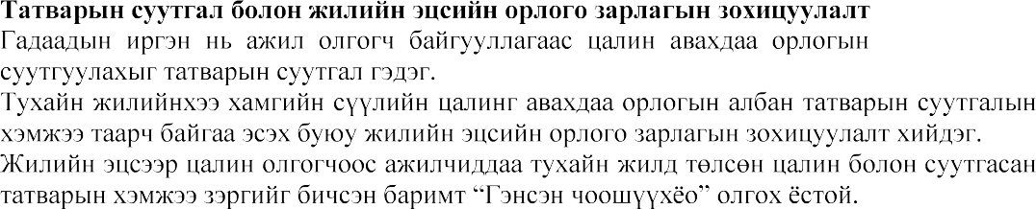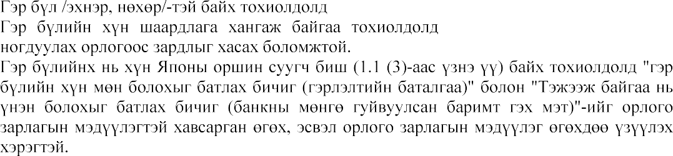

[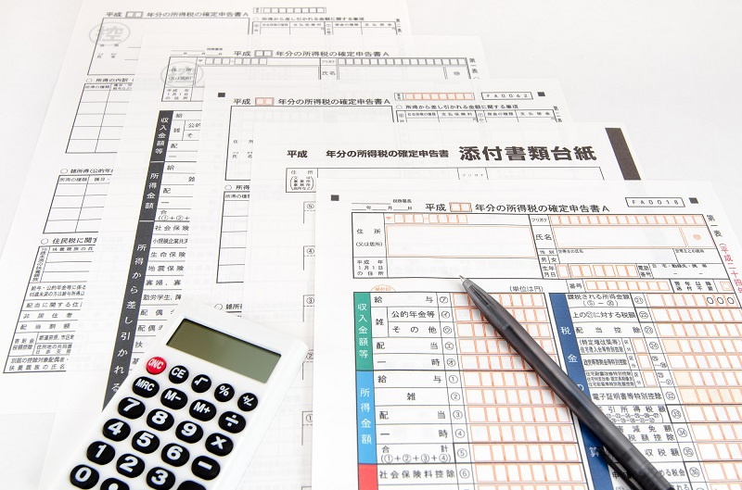](https://www.google.co.jp/url?sa=i&url=https://enechange.jp/articles/tax-return-income-tax&psig=AOvVaw1celQV7RrALeByXtkuTYIp&ust=1602751987097000&source=images&cd=vfe&ved=0CAIQjRxqFwoTCIDhnsvas-wCFQAAAAAdAAAAABAP)